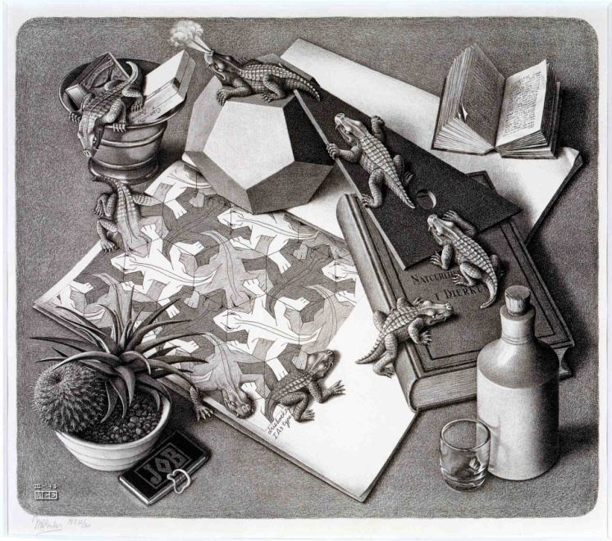 | Artist: Mc. Escher  Date: 1960  Title:“Reptiles”  The life cycle of a little alligator. Amid all kinds of objects a drawing book lies open, and the drawing on view is a mosaic of reptilian figures in three contrasting shades. Evidently one of them has tired of lying flat and rigid amongst his fellows, so he puts one plastic-looking leg over the edge of the book, wrenches himself free and launches out into real life. Then after a quick snort, tired but fulfilled, he goes to downhill again, via a ashtray, to the level surface, to that flat drawing paper, meekly rejoins his erstwhile friends, taking up once more his function as an element of surface division.  1
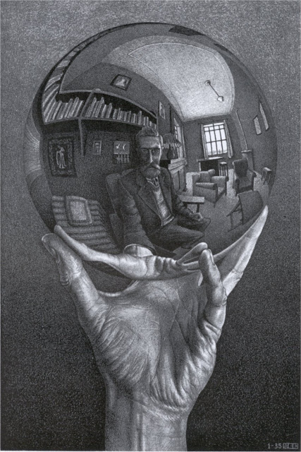 | Artist: MC Esher  Date:1960  Title “Hand with Reflecting Globe”  2
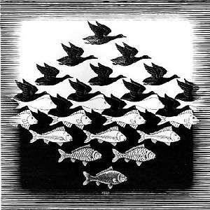 | Artist: MC Esher  Date: 1960  Title: “Sky and Water 1”  3
Artist: George Rodrigue
Title: “Watchdog”
Date: 2000

ABOUT THE ARTIST- George Rodigue: From New Iberia, Louisiana, Cajun Artist George (Blue Dog ) Rodrigue is known for his Blue-Dog series, inspired by Blue Dog's long-deceased childhood pet, Tiffany, whom he poses with other animals and people. Rodrigue had early art talent, and while ill for nearly a year, Blue Dog used watercolors and crayons to pass the time and pave the way to his future. For awhile George Rodrique painted Abstract Expressionist works but then went back to painting that which reflected his own Cajun culture including folk tales and bayou and swamp landscapes.
4
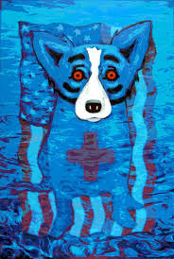 | Artist: George Rodrigue  Title: “We Will Rise Again”  Date: 2000  This painting was made after the destruction of hurricane Katrina hit New Orleans where the artist has his gallery. Prints were sold to raise money for the Red Cross.  5
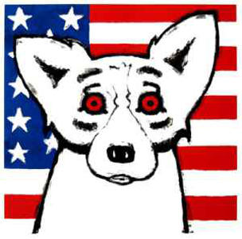 | Artist: George Rodrigue  Title: God Bless America  Date: 2000  This Painting was made in response to attacks on Sept 11, 2001. On that horrible day George painted “God Bless America”, surprising everyone, including himself, when the one thousand prints raised $500,000 for the American Red Cross in just a few weeks.  6  Framed Size : 33 x 31 in | 84 x 79 cm $3,400
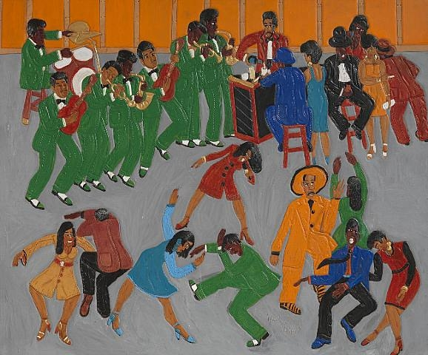 | Artist: Winfred Rembert  Title: “Jazz Dancing”  Date: 2000  A native of Cuthbert, Georgia, Winfred Rembert spent his childhood as a fieldworker in the pre-civil rights South. Brought up by his great-aunt ("Mama"), Rembert paints stories that look back to his youth in the days of segregation. Despite the often grim working conditions he encountered and years spent on a prison chain gang), Rembert's works focus on the joyous aspects of black life in the 1950s South — the strong family and community bonds, the cultural vibrancy, and the many colorful characters that lifted the spirits of those who had little choice but to labor in the region's cotton and peanut fields.  7  http://www.adelsongalleries.com/artists/winfred-rembert/biography/
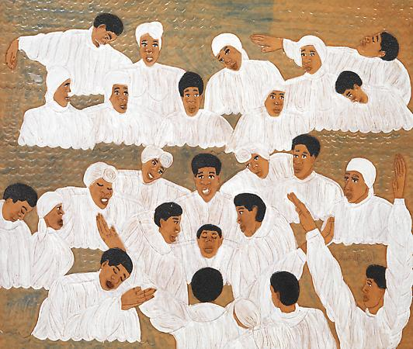 | Artist: Winfred Rembert  The Baptism , 2000  Dye on carved and tooled leather  29 1/4 x 34 3/4 inches  8
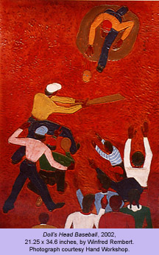 | Artist: Winfred Rembert  Title: Doll Head Baseball  Date: 2000  “I never saw a real baseball until I was walking past the white kids' schoolyard one day and saw some kids playing a game that looked like our ball game, but the ball was different from the rubber doll's head we used. The gloves also looked different—they weren't the paper bags we crimped and folded—and their bats weren't flat like our planks of wood. I wanted to ask them what they were throwing, but I was afraid of the white kids. So I began asking older black men, and finally Mr. Hargrove showed me a real baseball.  Doll's head baseball was definitely more fun than the real game. The older kids and adults used to play on weekends, and they were really good. They'd always bring a basket full of rubber heads, 'cause sometimes a head would tear up when you hit it. I loved to watch the game.” Winfred Rembert  9
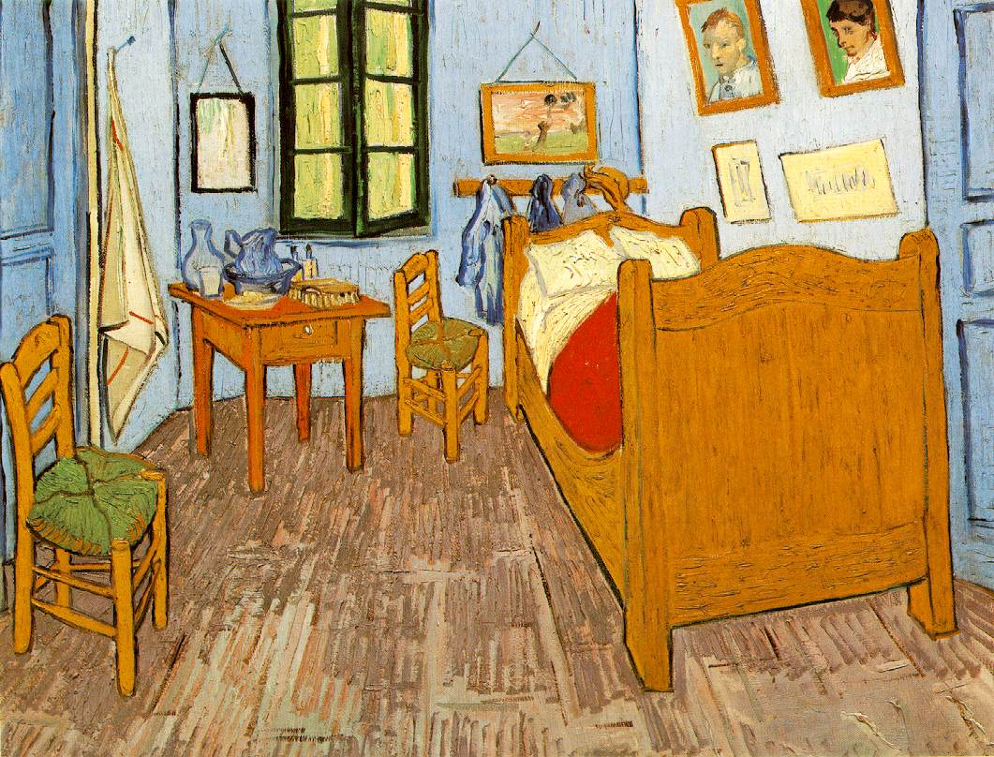 | Artist: Vincent Van Gogh (Dutch)  Title: The Bedroom  Date: 1880  10
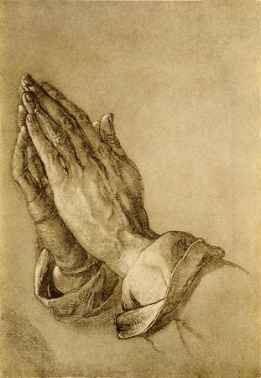 | Artist: Albrect Durer  Title: “Praying Hands”  1500  Albrecht was born the third of eighteen children the father of a goldsmith. His style as an artist was very original as well as precise.  Other works include: The Four Horsemen of the Apocalypse, the Four Apostles, the Young Hare, and Self-portraits.  11
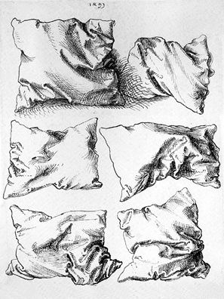 | Artist: Albrect Durer  “Six Pillows”  1500  Sechs Kissen “Six Pillows”  1500  Ink on paper, 2/6 x 202 cm  Durer was able to travel to Italy and admired the Italian artists. Durer’s goal was to raise the quality of art to Germany as well as an awareness of the art.  “Durer produced this wonderful drawing, essentially a study of drapery, when he was twenty-two years old”  12
Vincent Van Gogh
Starry Night
1880

13
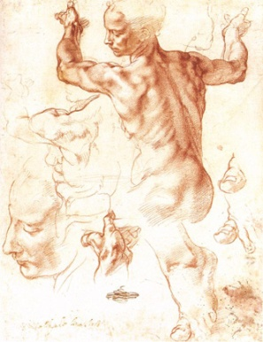 | Michelangelo  “Study for Libyan Sibyl”  1500  (Italian Renaissance) red chalk drawing Michelangelo was born into a poor family and at a young age knew he was going to be an artist. The Study for the Libyan Sibyl was a drawing done in preparation for the large fresco on the Sistine Chapel Ceilings that would contain a total of 400 figures. He would later paint the “Last Judgment” at the front of the chapel. Michelangelo did not care for painting but would rather sculpt in marble. His most famous sculptures are “David, “Pieta” and Moses.  14
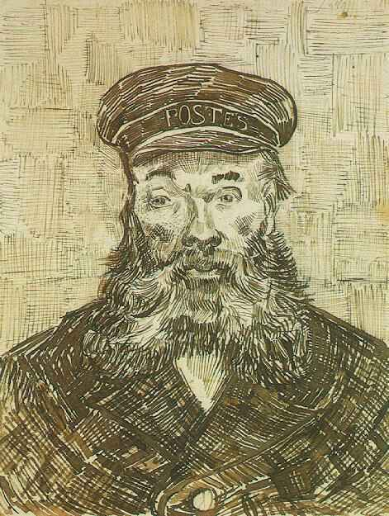 | Artist: Vincent van Gogh  Title: Joseph Roulin  Date: 1880  Drawing, Pen and Ink  Location: Getty Center  Los Angeles, California, United States of America  Vincent van Gogh, for whom color was the chief symbol of expression, was born in Groot-Zundert, Holland on March 30,1853.  15
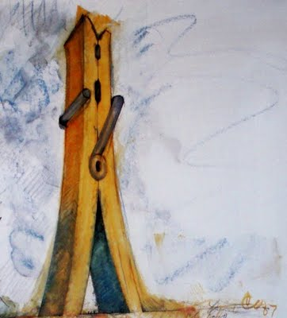 | Artist: Clas Oldenberg  Title: “Clothes Pin”  1960  Grew up in Chicago and later moved to New York. He enjoys making large sculptures of ordinary objects.  16
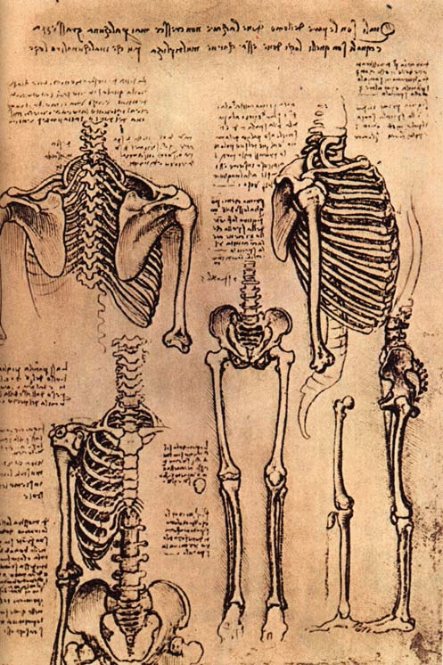 | Artist: Leonardo da Vinci  1500  Title: Bone Study  “A Renaissance Man” Meaning he was knowledgeable in all things.  Artist and Genius he was ahead of his time not only in painting, sculpture and architecture, but in engineering, military science, botany, anatomy, geology, aerodynamics and optics to mention only a few of the areas in which he made original contributions.  17
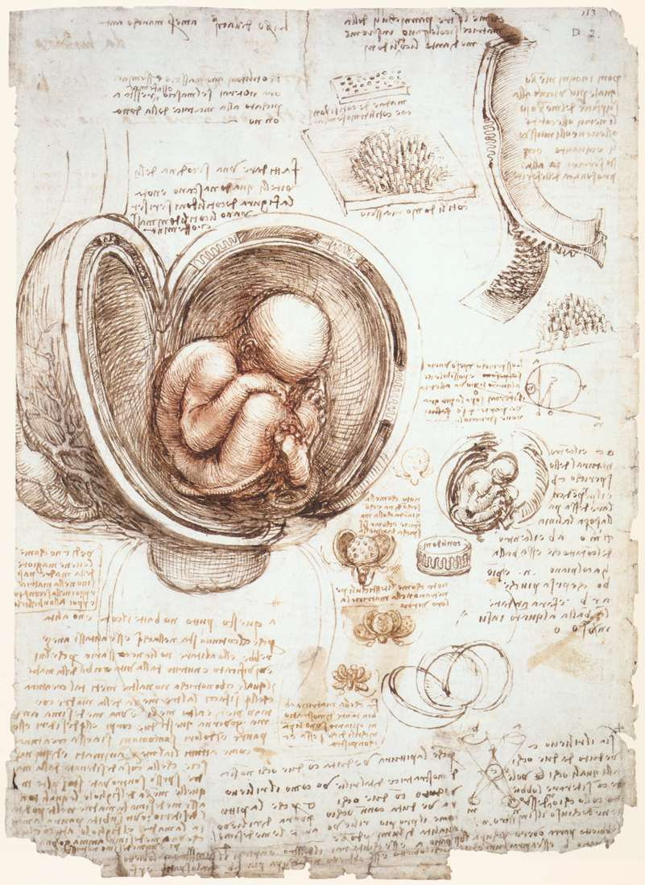 | Artist: Leonardo da Vinci  1500  Title: The Fetus in the Womb  (Note book Drawing)  Italian artist (From Italy)  (Windsor Castle, Royal library of Her Majesty the Queen of England)  Leonardo considered paint to be the supreme form of art; Michelangelo disagreed with him strongly on this because Michelangelo preferred marble sculpture.  18
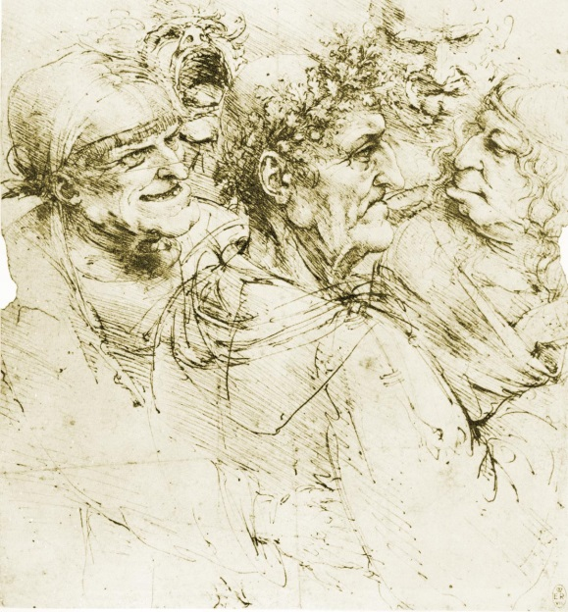 | Artist: Leonardo da Vinci  Title: “Five Grotesque Heads”  Date: 1500  Pen on white paper  (Windsor Castle, Royal library of Her  Majesty the Queen of England)  Leonardo is famous for his paintings such as the Mona Lisa and the last Supper. Of his works, only a few paintings survive, together with his notebooks containing drawings, scientific diagrams and notes. He left ten thousand pages of drawings, ideas, sketches and notes all written in left-handed in reverse or mirror image.  19
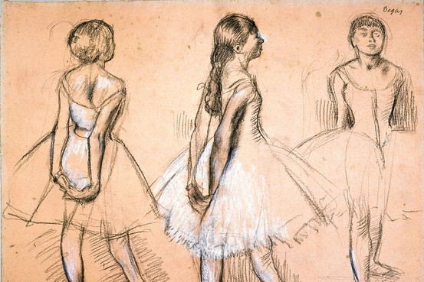 | Edgar Degas  Studies of a Dancer  1880  20
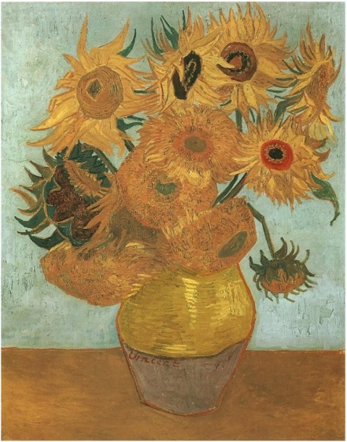 | Van Gogh  1880  Sun Flowers  21
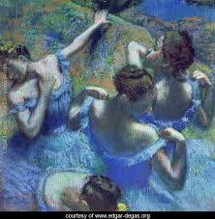 | Edgar Degas  Blue Dancers  1880  Degas carefully considered the compositions of his paintings by carefully placing his subjects.  22
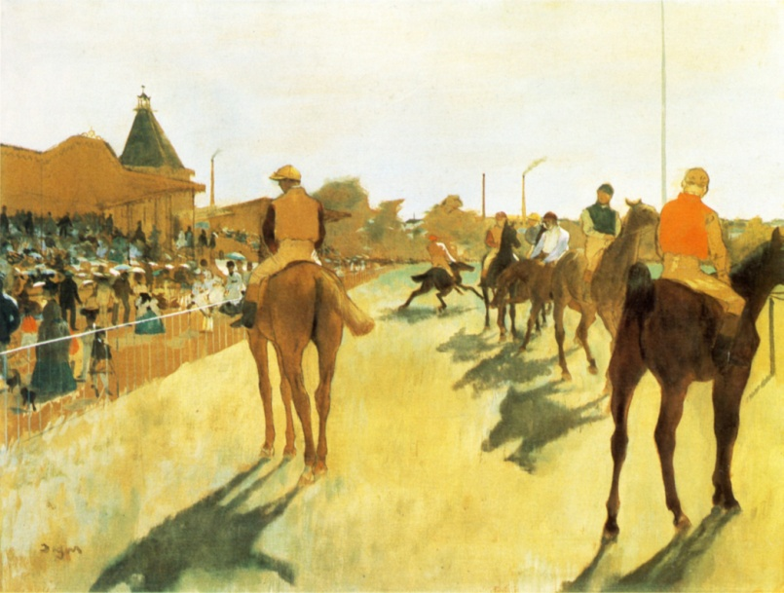 | Edgar Degas  Before the stands  1880  23
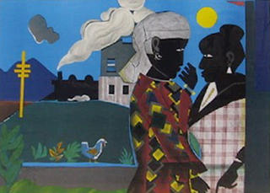 | “Conversations”  Romare Bearden  1960  (Advanced Art Only)  24
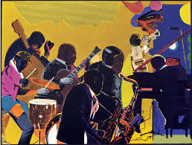 | “Out Chorus”  Romare Bearden  1960  (Advanced Art Only)  25
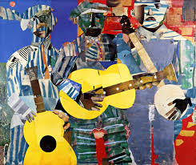 | “Three Folk Musicians”  Romare Bearden  1960  (Advanced Art Only)  26
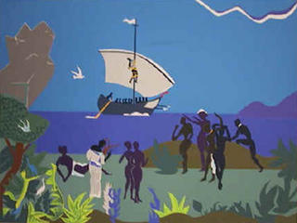 | “Siren's Song”  Romare Bearden  1960  (Advanced Art Only)  27  (From the Odyssey series)

