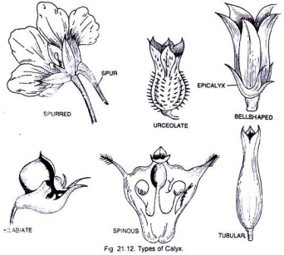  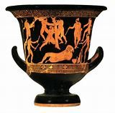  The upward curling of the bowl resembles the calyx of a flower and hence it is called the calyx krater. | Niobid Painter, Niobid Krater Questions-Khan Academy Video  What kind of Greek pottery is this?  Calyx Krater is a Greek wine bowl made in Athens, Greece about 444 BC. It is a bowl with a wide mouth, two handles which are placed low down on the body, and a foot. 444BC

What was this piece of

pottery used for?

What did Niobe do to cause

the death of her 14 children?

What did Apollo and

Artemis do?

How many Greek wall

paintings have survived?

How do we know about Greek wall painting?
How does the artist  create a since of  illusion in the Niobid Krater?  What is Herakles holding  that allows us to identify him? | 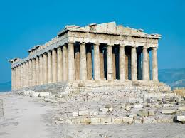  Parthenon, Athens 444 B.C.
Making Greek vases-Khan Academy Video  What was used to make Greek Vases?  - What had to be removed before the clay could be used?  - What it called when the potter mixes and compresses clay to make it malleable?  - How were Greek Vases formed?  - How did the Greek potters make the complex shaped vases? | - How did the potter join handles or  other clay parts to the vase?  - What 4 tools did the potter use when making a vase?  - Wheel, His hands, a sponge, metal scraper  - Fish bones, wheel, wires, flint  - String, Grass, Wheel and his hands  - The Greeks painted watery clay on their vase. When firing the pottery they created an oxygen rich environment in the kiln and then oxygen poor environment in the kiln to achieve what colors on their pottery.

