Greek Classical

Greek Classical

Greek Classical

Greek Classical

Greek Classical

Greek Classical

Greek Classical

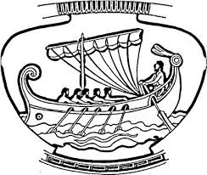[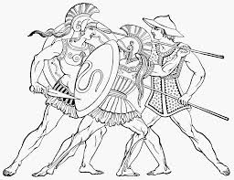](https://www.google.com/url?sa=i&rct=j&q=&esrc=s&source=images&cd=&cad=rja&uact=8&ved=2ahUKEwi-qODH2v_mAhXJg-AKHRe4CDgQjRx6BAgBEAQ&url=%2Furl%3Fsa%3Di%26rct%3Dj%26q%3D%26esrc%3Ds%26source%3Dimages%26cd%3D%26ved%3D2ahUKEwiMq7K72v_mAhUkWN8KHUd1BZgQjRx6BAgBEAQ%26url%3Dhttps%253A%252F%252Fwww.pinterest.com%252Fpin%252F387661480404714848%252F%26psig%3DAOvVaw3zPFzbvwhLlVxDOWl-OHRT%26ust%3D1578974897319199&psig=AOvVaw3zPFzbvwhLlVxDOWl-OHRT&ust=1578974897319199)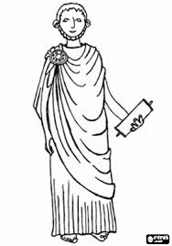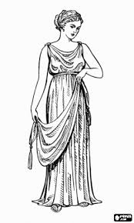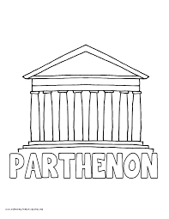 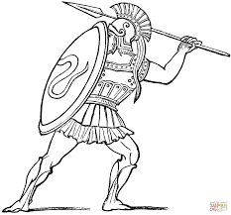 [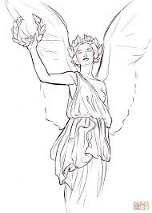](https://www.google.com/url?sa=i&rct=j&q=&esrc=s&source=images&cd=&cad=rja&uact=8&ved=2ahUKEwiD7Z7Z2v_mAhWvV98KHcaVCw4QjRx6BAgBEAQ&url=%2Furl%3Fsa%3Di%26rct%3Dj%26q%3D%26esrc%3Ds%26source%3Dimages%26cd%3D%26ved%3D2ahUKEwi-qODH2v_mAhXJg-AKHRe4CDgQjRx6BAgBEAQ%26url%3Dhttp%253A%252F%252Fwww.tobaccofreenow.org%252Fnike-greek-mythology%252Fnike-the-samothrace-miscellaneous-about-art%252F%26psig%3DAOvVaw3zPFzbvwhLlVxDOWl-OHRT%26ust%3D1578974897319199&psig=AOvVaw3zPFzbvwhLlVxDOWl-OHRT&ust=1578974897319199) [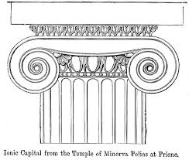](https://www.google.com/url?sa=i&rct=j&q=&esrc=s&source=images&cd=&cad=rja&uact=8&ved=2ahUKEwiF0KTo2v_mAhWFdt8KHZBfDIIQjRx6BAgBEAQ&url=https%3A%2F%2Fcommons.wikimedia.org%2Fwiki%2FFile%3AIonicCapitalPriene.jpg&psig=AOvVaw3zPFzbvwhLlVxDOWl-OHRT&ust=1578974897319199)