Augustus of Prima Porta is a full-length portrait statue of Augustus Caesar, the first emperor of the Roman Empire. The marble statue stands 2.08 meters tall and weighs 1,000 kg. The statue was discovered on April 20, 1863 at the villa suburbana owned by Augustus’ third wife, Livia Drusilla in Prima Porta, near Rome.  Questions that go with the video Augustus of Primaporta Khan Academy.com  What was Augustus’ role in the Roman Empire? __  - Senator b. on the Council of Elders  c. Emperor d. Rich Merchant  - How does the sculpture portray Augustus? _______________________  a. Weak b. as a believer in Christ  c. God like, strong and leader d. an Elder  3. In 509 BC Roman Republic established and ruled by____  a. Senate or Council of Elders b. President  c. Judges d. King  4. In 30 BC The Roman Empire was a established and  ruled by ______  a. Sole Ruler Augustus Caesar b. Elected Prime minister  c. Council d. Witch doctor  5. What was the purpose of the sculpture of Augustus?  a. Wise and elderly b. Realistic moles in all  c. To portray him as young, handsome, strong leader  6. What famous sculpture does the statue of Augustus mimic?  a. David by Michelangelo b. Athena  c. "Doryphoros" by Polykleitos d. Clothes pin by Oldenburg 7. Why is cupid at his feet? ______________________  a. for good luck b. to portray Augustus as being a god  c. so people would fall in love with him  8. What images are on Augustus’ breast plate? ________  a. Images of gods and victories b. flowers  c. a map of the empire d. his hit list  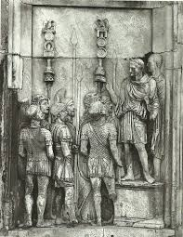  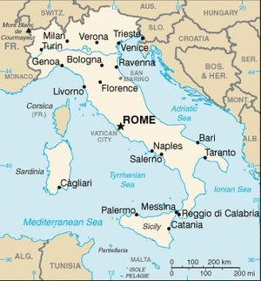  9. How is the sculpture Augustus visual propaganda? | 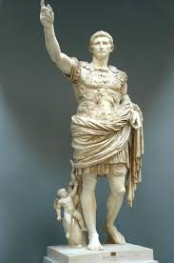  Augustus of Primaporta 126AD Roman Classical
Roman Soldiers holding “Standards”

