Roman Classical

Roman Classical

Roman Classical

Roman Classical

Roman Classical

Roman Classical

Roman Classical

Roman Classical

Roman Classical

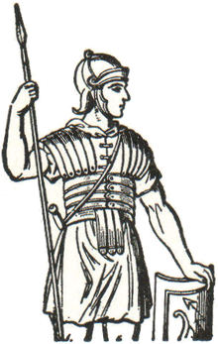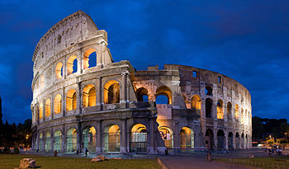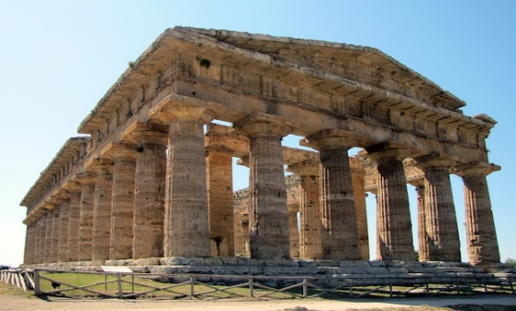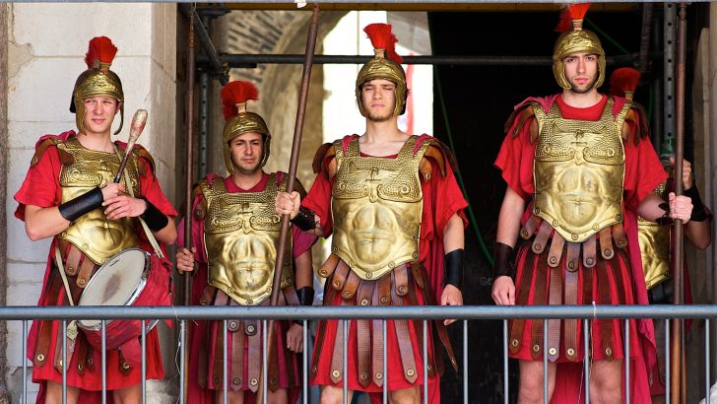

[This Photo](https://www.travelthewholeworld.org/2016/10/8-things-to-do-in-croatia.html) by Unknown Author is licensed under [CC BY](https://creativecommons.org/licenses/by/3.0/)

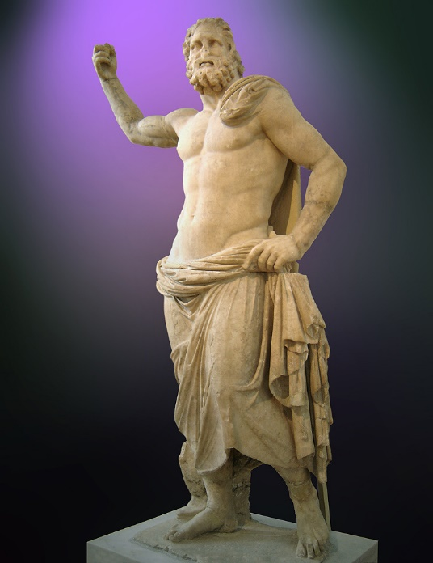

[This Photo](https://en.wikipedia.org/wiki/Poseidon) by Unknown Author is licensed under [CC BY-SA](https://creativecommons.org/licenses/by-sa/3.0/)

