Khan Academy Video – Justinian Mosaic  1 The San Vitale church is located in Ravenna, _________________  2 San Vitale Church was built during the 6th century which is during what years? a. 501AD-600AD b. 601AD-700AD c. 401AD-500AD  3 The plan for the church is not like a typical basilica which would be in the shape of a cross. The outside of San Vitale is the shape of an… a Octagon b. Square c. Pentagon d. Semi Circle  4 The eastern end of the Byzantine church San Vitale is filled with _________. a. Mural paintings b. Wood inlay designs c. Mosaic  5 The columns used in the Byzantine Church… a. Copy Greek and roman styles b. leave behind Greek and Roman Designs to invent their own style.  6 How can we identify the Emperor Justinian in this Byzantine mosaic? a. he is bald b. he is taller than everyone else c. he is wearing purple, in the center and wearing a halo  7 What is the Emperor holding in the Byzantine mosaic? - Cup b. Cat - Bowl of bread d. Bible  8 Byzantine Empire is at the same time as the ___________ time period. a. Renaissance b. Medieval c. Rocco time period  9 What is the mosaic made of? - Macaroni b. puzzle pieces c. colored and gold glass  10 Theodora ruled as _____________. - Co-equal to the Emperor - a Queen who was seen but on heard  11 How can we identify Theodora in this Byzantine mosaic? - Holding a child b. Large hair style c. Dressed in purple and wearing jewels with a halo  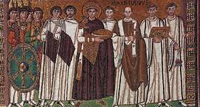  Justinian Mosaic 546 BC  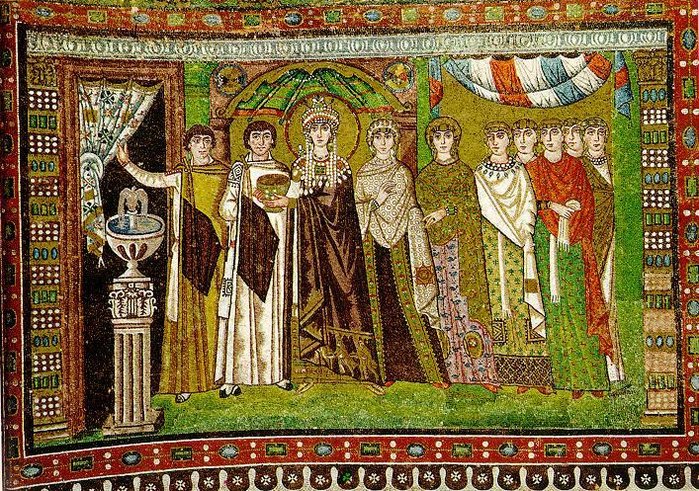 | Byzantine Art  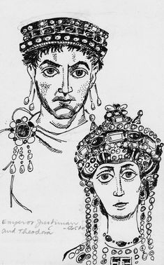Justinian Mosaic  546 BC  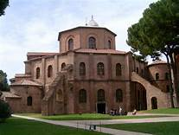
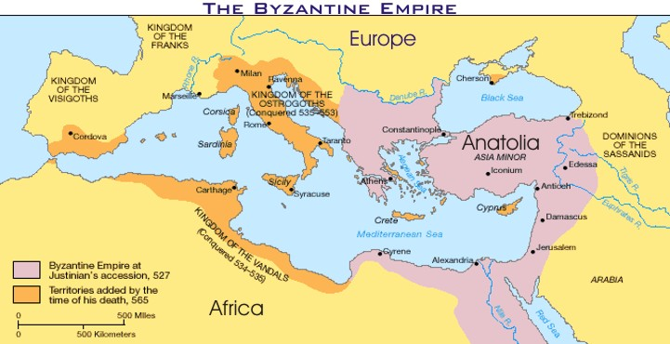

Justinian and the Byzantine Empir
0 energy points

Justinian and the Byzantine Empire
0 energy points

Justinian and the Byzantine Empire
0 energy points

Justinian and the Byzantine Empire
energy points

Justinian and the Byzantine Empire

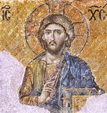
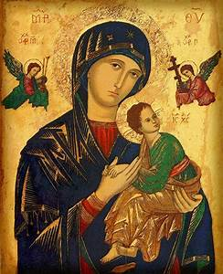
During the Byzantine time period the only images that could be made where ones that were approved. Many pieces were copies of approved list of s objects.

