Celtic

Celtic 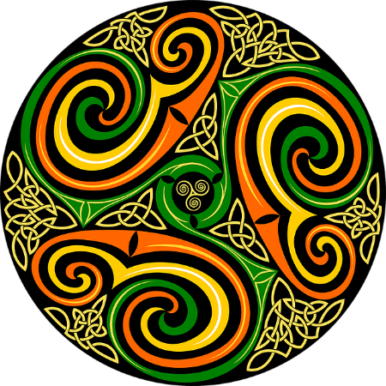

Celtic

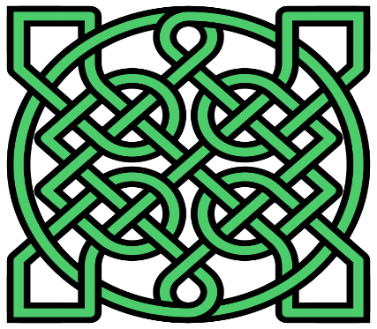

[This Photo](https://en.m.wikipedia.org/wiki/File:Celtic-knot-insquare-39crossings.svg) by Unknown Author is licensed under [CC BY-SA](https://creativecommons.org/licenses/by-sa/3.0/)

Celtic 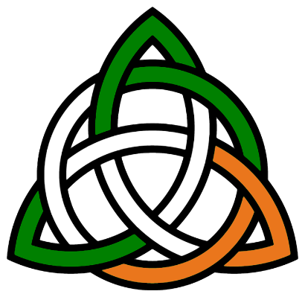

Celtic

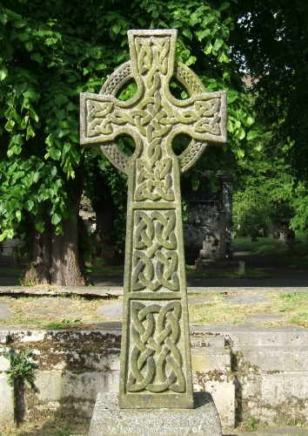

[This Photo](https://en.wikipedia.org/wiki/Celtic_knot) by Unknown Author is licensed under [CC BY-SA](https://creativecommons.org/licenses/by-sa/3.0/)

Celtic

Celtic

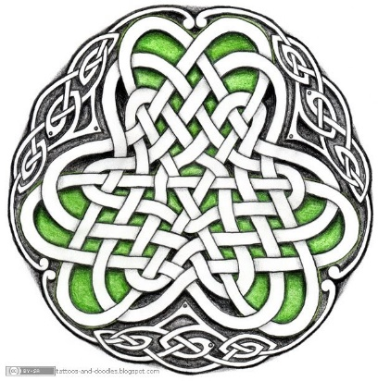

[This Photo](http://tattoos-and-doodles.blogspot.com/2010/05/celtic-circle-irish-shamrock.html) by Unknown Author is licensed under [CC BY-SA](https://creativecommons.org/licenses/by-sa/3.0/)

Celtic

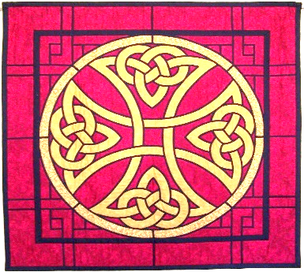

[This Photo](https://richardlfloyd.com/category/uncategorized/) by Unknown Author is licensed under [CC BY-NC-ND](https://creativecommons.org/licenses/by-nc-nd/3.0/)

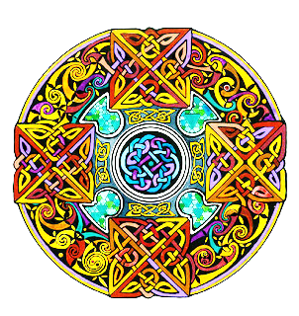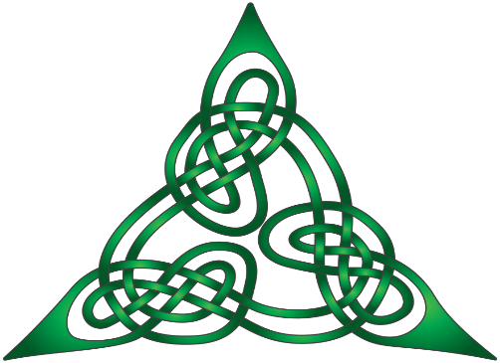

[This Photo](https://en.wikipedia.org/wiki/File:Lindisfarne_StJohn_Knot2_3.svg) by Unknown Author is licensed under [CC BY-SA](https://creativecommons.org/licenses/by-sa/3.0/)