Khan Academy Video - The Bayeux Tapestry  1 King Edward dies leaving who in charge? Shrek b.King Aurther c. King Harold  2 What is this a symbol of? - Hand of God b. kings orders c. alien hand  3 Why are these men cutting down trees? - To build ships - To clear land to farm - They don’t like trees  4 What are these men wearing? - Latest fashions from Paris - Chainmail - Striped wool suits  5 After William and his ships land in England, what do they do next? - Attack the castle - Eat a feast - Have a horse race  6 Why is William riding his horse backwards? - He is a gifted trick rider - He got extra points for riding Backwards - To show himself to the army to Prove he was not dead  7 How does king Harold die? - Beheaded - Drowned - Drinks poison - Shot in the Eye with an arrow  Map of England - Battle of Hastings Oct 1066  during the Conquest of William the Conquer  5,000 Saxons traveled from York to Hastings to fight  Williams 15,000 Soldiers that had invaded from Normandy.  There were 700 Ships that brought over the soldiers  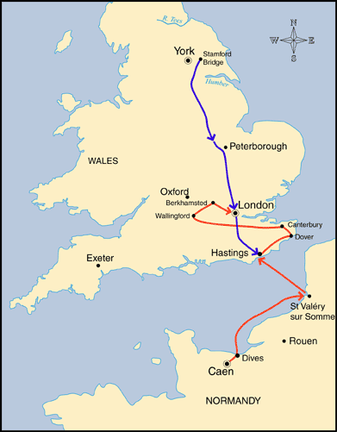 | 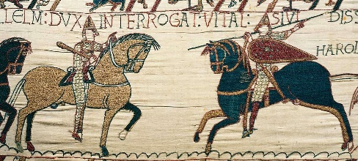  Romanesque Art  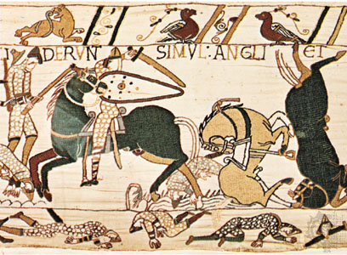  Bayeux (Buyer) Tapestry  1070 AD  The Story of William the Conquer  the first Norman King of England
