Bishop Barron on Notre Dame Rose Window  1 Is Notre Dame a Catholic Cathedral? True b. False  2 What is the name of the stained glass window? - Rose Window b. Saint James Window c. Roman Window  3 What shape is the window? - Oval b. Rectangular c. Circular d. Octagonal  4 How many small windows make up the window of Notre Dame? - 88 b. 12 c. 144 d. 48  5 Where is the Cathedral located? - Germany b. Paris c. Boston d. Rome  6 What does the number 8 represent? - Eternity b. Sin c. Grace d. Mercy  7 What did the saints comprehend about God? - He is incomprehensible b. He is merciful c. He brings prosperity  8 What are the main color scheme of the window? - Warm colors - Neutral colors - Cool colors  Khan Academy Video  The Cathedral of Notre-Dame, Paris (before the fire)  1 Who Founded the city of Paris on the island of llede la cite in 1163? - Goths b. Romans c. King Harold d. Napoleon  2 The Church is a symbol of what? - Theological and Worldly Power b. Roman Wealth c. American Ideology  3 Who was crowned king in Notre-Dame in 1804? - Napoleon b. William the Conquer c. The Pope D. King Lear  4 During what event was Notre-Dame attacked? - French Revolution b. French and Indian War c. War of 1812  5 What painting features Notre-Dame in the background? - Delacroix’s Liberty leading the people - Edvard Munch’s Scream - Van Gogh’s Starry Night  6 Notre-Dame was the tallest Cathedral when it was built. How tall is the Nave? a. 32.7 meters. b. 12 meters c. 100 meters  7 What part of the church bears the weight of the high ceiling? a. Thick cement walls b. 5 meter thick columns c. Flying buttresses  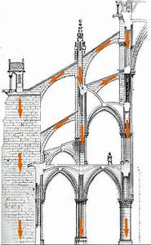  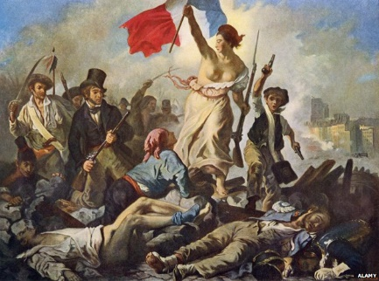 | 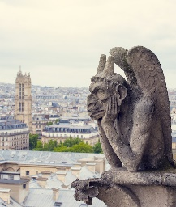  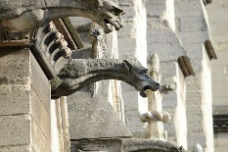  Gothic Art  1300 AD  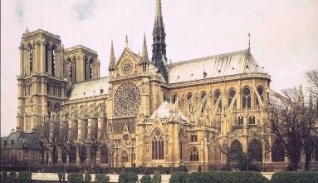  Notre Dame Cathedral
 | 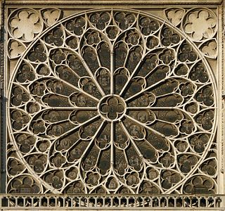
 | 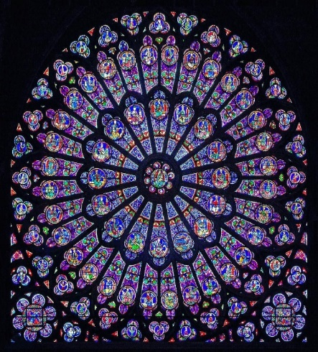
 | 