Hokusai
“Great wave”
1830
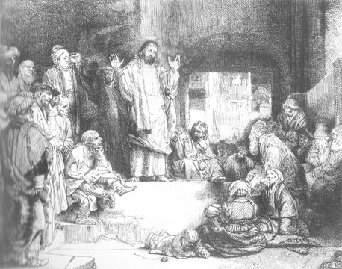 | Rembrandt  “Christ Preaching”  1650
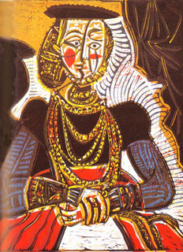 | Pablo Picasso  “Portrait of a young Girl”  1960
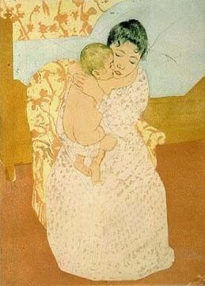 | Mary Cassatt  “Maternal Caress”  1900
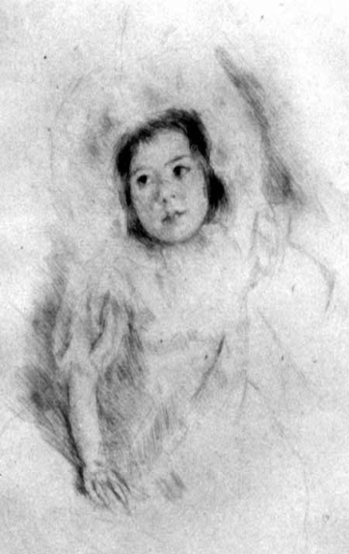 | Mary Cassatt  “Margo wearing a Bonnet”  1900
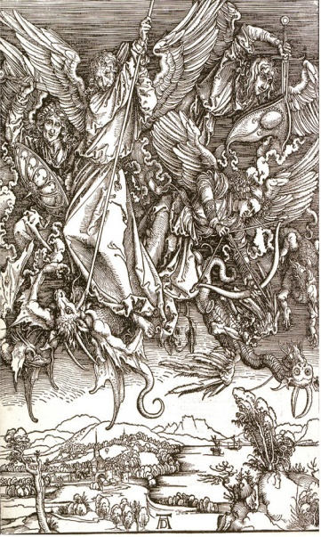 | Albrecht Durer  “Michael fighting the dragon”  1500
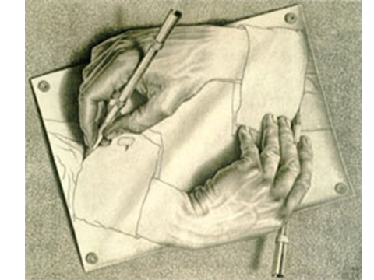 | M.C. Escher  “Hands”  1960
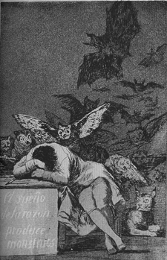 | Francisco Goya  The Sleep of Reason Produces monsters  1800
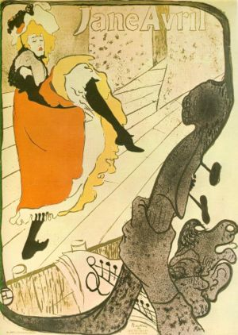 | Henri de Toulouse-Lautrec  “Jane Avril”  1900
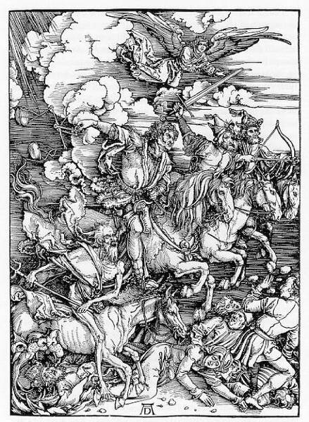 | Albrecht Durer  The Four Horseman of the Apocalypse  1500
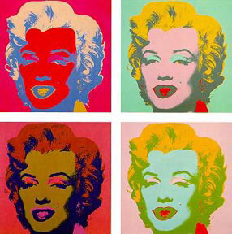 | Andy Warhol  “Marilyn”  1960

