My character’s name is:

ME character was in the book

By

Some word to describe my character

**Alice Buckley’s**

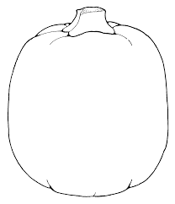**Pumpkin Parade**

**Character Report**