Renaissance

Renaissance

Renaissance

Renaissance

Renaissance

Renaissance

Renaissance

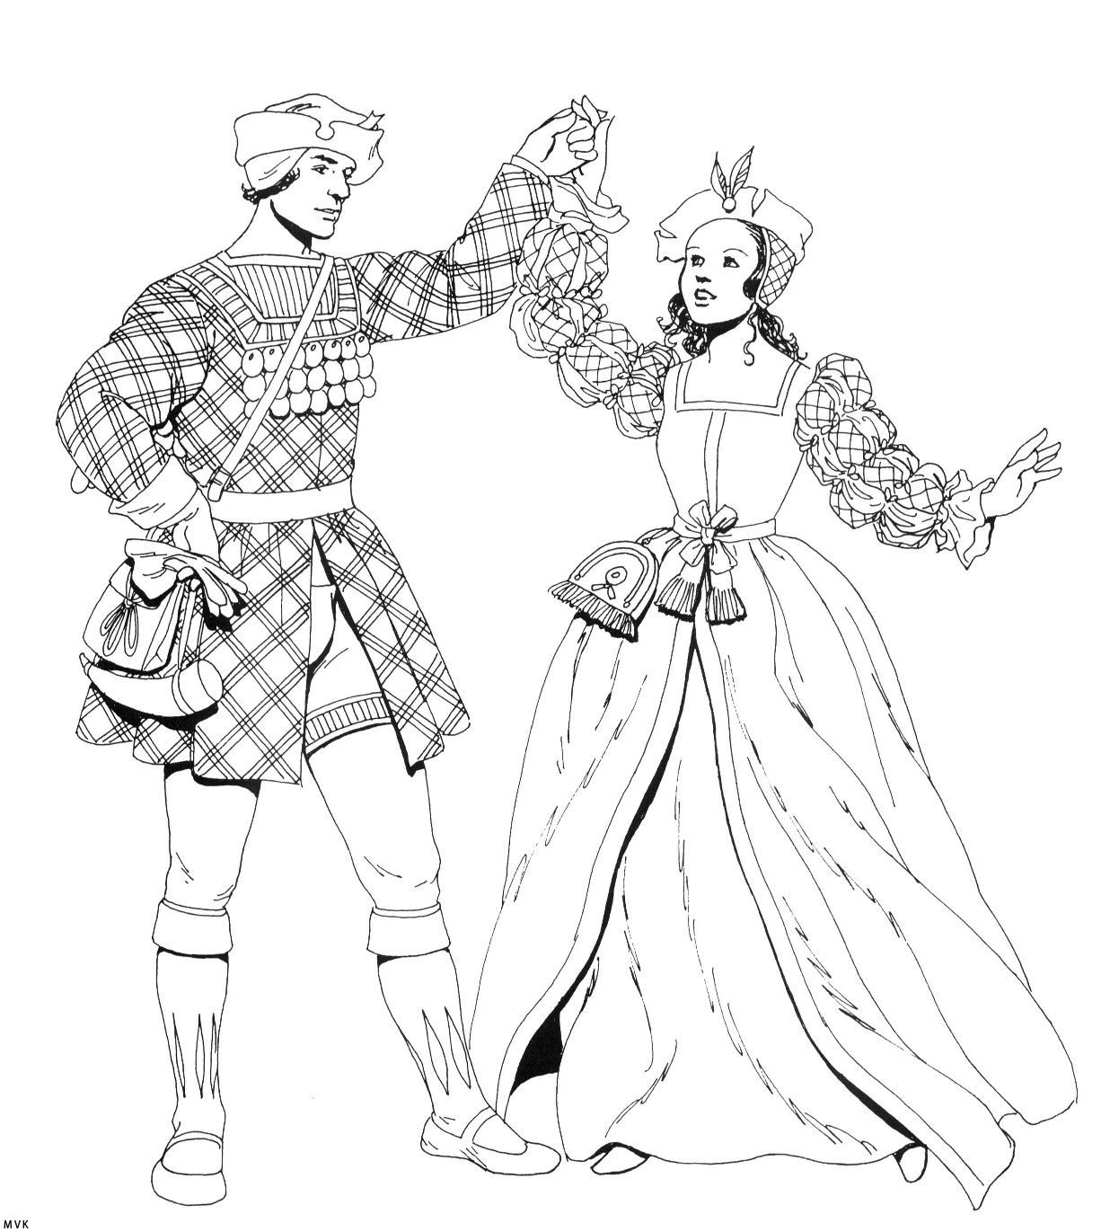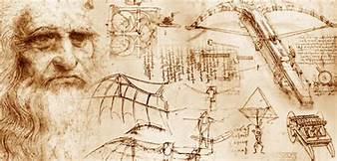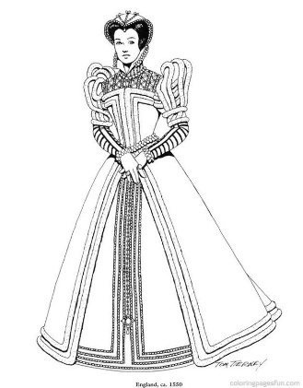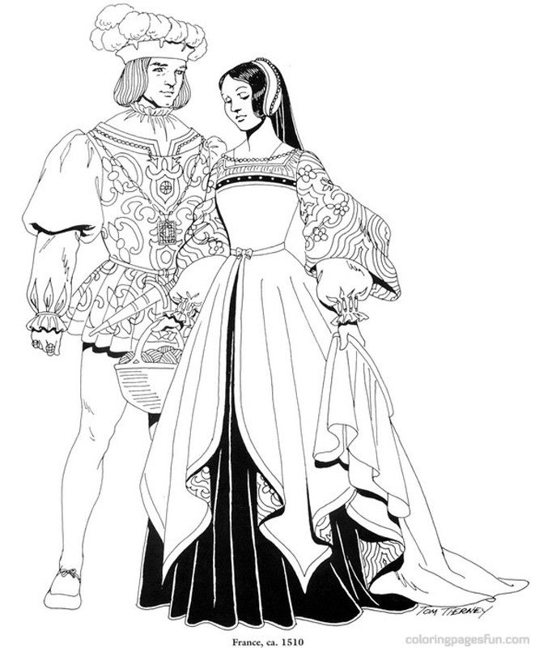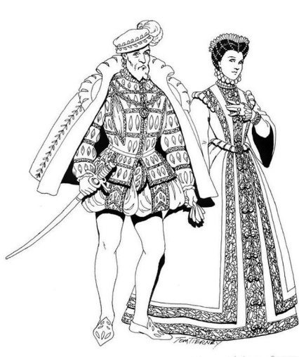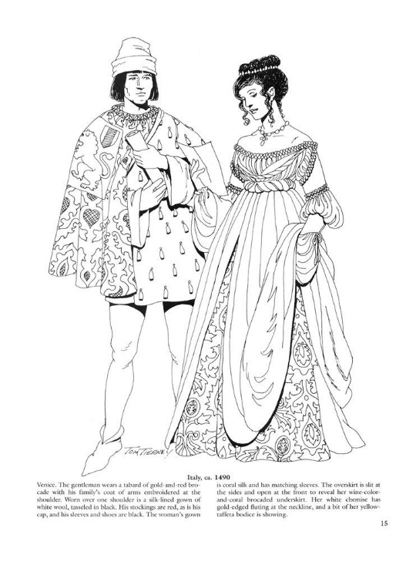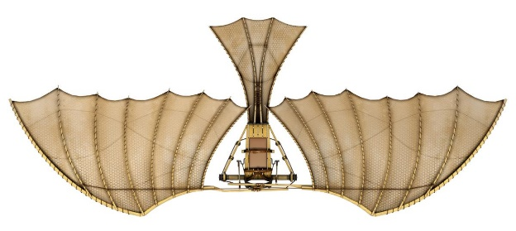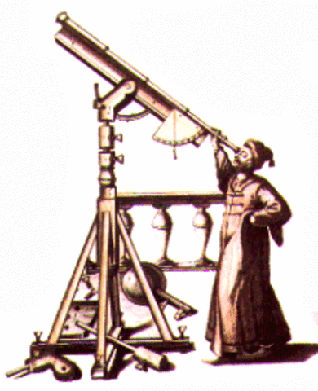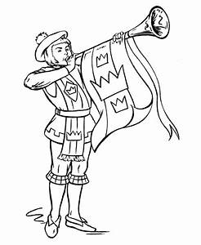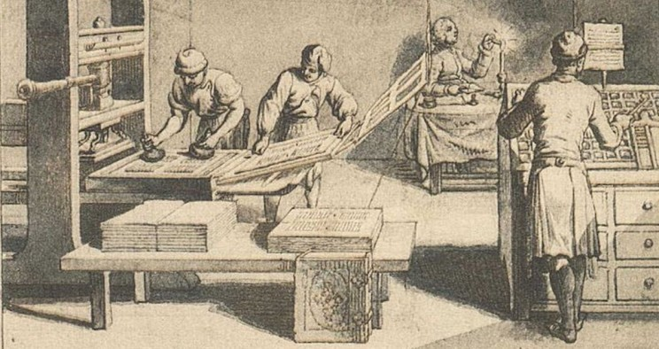[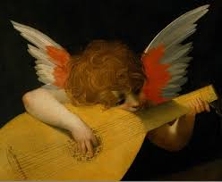](https://www.google.com/imgres?imgurl=https%3A%2F%2Fwww.akg-images.com%2FDocs%2FAKG%2FMedia%2FTR5%2F1%2Fa%2Ff%2F3%2FAKG324290.jpg&imgrefurl=https%3A%2F%2Fwww.akg-images.com%2Farchive%2FPutto-playing-lute-2UMDHURCBIH3.html&tbnid=aVITzB37l_jxnM&vet=10CAMQxiAoAGoXChMIwNqqif7H5wIVAAAAAB0AAAAAEBk..i&docid=S5O6pBWfQFOl-M&w=418&h=344&itg=1&q=renaissance&safe=strict&ved=0CAMQxiAoAGoXChMIwNqqif7H5wIVAAAAAB0AAAAAEBk)[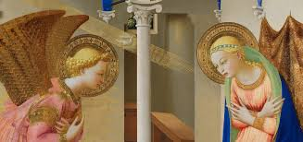](https://www.google.com/url?sa=i&url=https%3A%2F%2Fwww.museodelprado.es%2Fen%2Fwhats-on%2Fexhibition%2Ffra-angelico-and-the-rise-of-the-florentine%2Fc8c45536-59a2-5e3a-9615-6daf8c3ef9e9&psig=AOvVaw1YmfwY8M5LCb6TGlaUY63D&ust=1581458440757000&source=images&cd=vfe&ved=0CAIQjRxqFwoTCMDaqon-x-cCFQAAAAAdAAAAABAE)[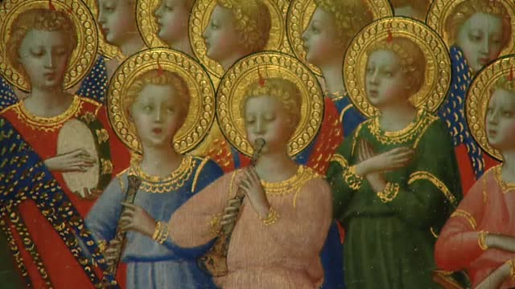](https://www.google.com/url?sa=i&url=https%3A%2F%2Fwww.publico.es%2Fvideos%2F772154%2Fel-museo-del-prado-presenta-la-exposicion-fra-angelico-y-los-inicios-del-renacimiento-en-florencia&psig=AOvVaw1YmfwY8M5LCb6TGlaUY63D&ust=1581458440757000&source=images&cd=vfe&ved=0CAIQjRxqFwoTCMDaqon-x-cCFQAAAAAdAAAAABAK)